

**Document Title** Project Functional Specification

**Revision** 2

**Date Issued** January 23, 2015

**Date Effective** January 23, 2015

**Department** School of Engineering and Information Technology

**Program** Electronic Systems Engineering

**Audience** ESE Semester 4 Faculty

**Author** Marcin Czajkowski, Student

**Reviewers** Mike Jarabek, Professor

Peter Roeser, Professor

Bill Stefanuk, Professor

**Revision History**

|  |  |  |
| --- | --- | --- |
| **Revision** | **Description of Change** | **Effective Date** |
| 1 | New Document Release | Jan. 16, 2015 |
| 2 | BOM, schematics and hardware spec updates | Jan. 23, 2015 |
|  |  |  |
|  |  |  |
|  |  |  |
|  |  |  |
|  |  |  |
|  |  |  |
|  |  |  |



Contents

1. Introduction: 3

2. Scope of the Document: 3

3. Chapter I – List of Related Documents 4

3.1. Purpose: 4

3.2. Documents list: 4

4. Chapter II – Cost Target 4

4.1. Purpose: 4

4.2. BOM 4

4.3. Total cost target 5

5. Chapter III - Specifications and Performance 5

5.1. Purpose: 5

5.2. Hardware Specifications: 6

5.2.1. Ports: 6

Ports assignment cont… 7

5.2.2. Communication and cabling: 7

5.2.3. Hardware configuration: 7

5.2.4. Physical Constraints: 8

5.2.5. PCB Design 8

• DC motor encoder 12

5.2.6. Power requirements 12

5.3. Software Specifications 13

5.3.1. Programming environment 13

6. Chapter IV – Regulatory Requirements 13

6.1. Purpose: 13

6.2. ESD Requirements 13

6.3. Soldering Requirements 13

7. Reliability and Service 13

# Introduction:

As part of the semester for year 2 for studies in Electronic Systems Engineering it is required to implement a project that will give students the opportunity to study and apply design principles for the creation of embedded systems hardware and software.

Additional tasks that a student will be learning through implementation of the project are:

* Populate and test PCB boards
* Design and simulate test diagnostic systems
* Use schematic capture as well as read specification of parts/systems vendors
* Create PCB manufacturing data
* Create a detailed documentation regarding project specifications and scheduling of the project

# Scope of the Document:

The scope of the Project Functional Specification document is to present hardware specifications needed to implement the HCS12 embedded PCB. This document will be subjected to numerous revisions as the project progresses and the aspects of the project are added through the semester. This document shall include:

* List of related documents supporting the project
* Cost targets of the components and services needed to finish the project
* Configuration options of the embedded system
* Detailed specification such as:
  + Performance
  + Port usage
  + Communication options
  + External cabling details
  + Physical size and physical constraints
  + Power requirements
* Regulatory requirements
* Reliability and service

# Chapter I – List of Related Documents

## Purpose:

The purpose of this chapter is to attach documentation related to the project. The documentation will be attached as links. Some documents might require special access permissions to be viewed. Contact document author if issues persist.

Author: Marcin Czajkowski

Email: [mczajkowski@conestogac.on.ca](mailto:mczajkowski@conestogac.on.ca)

## Documents list:

|  |  |  |  |  |
| --- | --- | --- | --- | --- |
| **#** | **Document tile** | **Revision** | **Document purpose** | **Link** |
| 1 | LM22675 Specs | L | To present specifications of LM22675 | [link](http://www.ti.com/product/lm22675) |
| 2 | Project Charter | 2.7 | To present project IV requirements | [link](https://conestoga.desire2learn.com/d2l/le/content/70973/viewContent/1442104/View) |
| 3 | Notes For Design Verification | 5.0 | MCU pin specifications | [link](https://conestoga.desire2learn.com/d2l/le/content/70973/viewContent/1442121/View) |
| 4 | Port Mapping | 6 | Port mapping and pin outs of the MCU | [link](https://conestoga.desire2learn.com/d2l/le/content/70973/viewContent/1442116/View) |
| 5 | PCB tolerances and design requirements | N/A | PCB design and tolerances | [link](https://conestoga.desire2learn.com/d2l/le/content/70973/viewContent/1442114/View) |
| 6 | DC motor encoder connections | N/A | Pin out of the DC motor connector | [link](https://conestoga.desire2learn.com/d2l/le/content/70973/viewContent/1442115/View) |
| 7 | Board outline | 8 | PCB outline and connector placements | [link](https://conestoga.desire2learn.com/d2l/le/content/70973/viewContent/1442117/View) |
| 8 | Camera conx pinout | 2 | Camera connection pin out | [link](https://conestoga.desire2learn.com/d2l/le/content/70973/viewContent/1442118/View) |
| 9 | Motor encoder | N/A | Motor speed feedback diagram | [link](https://conestoga.desire2learn.com/d2l/le/content/70973/viewContent/1442120/View) |
| 10 | MAX3232 | 7 | MAX3232 Data Sheet | [link](http://datasheets.maximintegrated.com/en/ds/MAX3222-MAX3241.pdf) |
| 11 | Altium Resource/Documentation | N/A | Webpage for Altium Designer support | [link](http://techdocs.altium.com/) |
| 12 | Absolute Maximum Ratings for Soldering SNOA549C | N/A | Soldering ratings for National Semiconductors | [link](http://www.ti.com/lit/an/snoa549c/snoa549c.pdf) |
| 13 | L293DD Driver | N/A | Stepper motor driver specifications | [link](http://www.st.com/web/en/resource/technical/document/datasheet/CD00000059.pdf) |
| 14 | L6225 Driver | N/A | DC motor driver specifications | [link](http://www.st.com/web/en/resource/technical/document/datasheet/CD00003310.pdf) |

# Chapter II – Cost Target

## Purpose:

The purpose of the Cost Target chapter is to track the expenses of the parts and services required to finish the project. This chapter will keep an updated BOM as well as any quotes obtained from the vendors.

## BOM

|  |  |  |  |
| --- | --- | --- | --- |
| Comment | Footprint | LibRef | Quantity |
| Cap | CAPC2012X09M | CAP-X7R-47000pF-50V-±10%, CAP-X7R-.1uF-100V-±10%, CAP-X7R-5600pF-50V-±10%, CAP-X7R-5600pF-50V-±10%, CAP-X7R-.1uF-50V-±5%, CAP-X7R-.1uF-50V-±5%, CAP-COG-220pF-50V-±5%, Cap, CAP-X7R-.1uF-16V-±10%, Cap, CAP-COG-22pF-50V-±5%, CAP-COG-22pF-50V-±5%, CAP-X7R-2.2uF-16V-±10%, CAP-X7R-10000pF-50V-±10%, CAP-X7R-10000pF-50V-±10%, CAP-X7R-1uF-16V-±10%, CAP-X7R-1uF-16V-±10%, CAP-X5R-10uF-10V-±10%, CAP-X5R-10uF-10V-±10% | 19 |
| Cap Pol | CAPACITOR_3MM | Cap Polar-0.33uF-50V, Cap Polar-0.33uF-50V, Cap Polar-0.33uF-50V, Cap Polar-0.1uF-50V | 4 |
| Cap | C1210 | CAP-X7R-2.2uF-16V-±10% | 2 |
| Cap Pol | CAPACITOR_6.3MM | Cap Polar-100uF-16V | 1 |
| TANT. |  | CAPACITOR POL | 3 |
| **BOM Cont…** | | | |
| DIODE SCHOTTKY 40V 2A SMA | DIOM4326X23M | DIODE SCHOTTKY 40V 2A SMA | 2 |
| Diode 1N4148 | zener_sod323 | Diode 1N4148 | 2 |
| H3x2 | HDR2X3 | Header 3X2 | 1 |
| VRH_EN | HDR1X2 | Header 2 | 1 |
| VRL_EN | HDR1X2 | Header 2 | 1 |
| Header16_LCD_Header | HDR1X16_LCD | Header16_LCD | 1 |
| Header 3 | HDR1X3 | Header 3 | 1 |
| Header 2 | HDR1X2 | Header 2 | 4 |
| D Connector 9 | DSUB1.385-2H9 | D Connector 9 | 1 |
| SRN8040 | INDP8080X40M | SRN8040 | 2 |
| 10uH |  | INDUCTOR | 1 |
| Res3 | RESC2112X05M | Resistor_10.0K, Resistor_10.0K, Resistor_10.0K, Resistor_10.0K, Resistor_10.0K, Resistor_10.0K, Resistor_10.0K, Resistor_100R, Resistor_100R, Resistor_5.11K, Resistor_475R, Resistor_5.11K, Resistor_475R, Resistor_221R, Resistor_4.75K, Resistor_10.0K, Resistor_10.0K, Resistor_1.00K, Resistor_1.00K, Resistor_2.87K, Resistor_2.87K, Resistor_100R | 22 |
| RPot | BOURNS_3386F | RPot | 1 |
| R_XLT1 | RESC2112X05M | Resistor_10.0K | 1 |
| R_XLT2 | RESC2112X05M | Resistor_1.02R | 1 |
| SWITCH_TACTILE |  | SWITCH_TACTILE | 1 |
| L293DD | SO20_N | L293DD | 1 |
| L6225 | POWERSOP20 | L6225 | 1 |
| DS1813-10 | SOT95P230X110-3M | DS1813-10 | 1 |
| MC9S12C128MFUE | QUAD.65M/80/WG17.45-HCS12 | MC9S12C128MFUE | 1 |
| 74ACT14_3 | SOIC127P600X175-14M | 74ACT14_3 | 2 |
| LM22675MR-ADJ/NOPB | MRA08B_L | LM22675MR-ADJ/NOPB | 2 |
| MAX3232CSE | NSO16_N | MAX3232CSE | 1 |
| CRYSTAL/SM |  | CRYSTAL/SM | 1 |
| **Current Total Cost: $65.46** | | | |

## Total cost target

Currently the cost target of the finished product is approximately $200. The above estimate presents only the current known parts that must be acquired.

# Chapter III - Specifications and Performance

## Purpose:

The purpose of this chapter is to present detailed hardware and software specifications regarding configurations, ports usage, cabling details and system communications.

## Hardware Specifications:

### Ports:

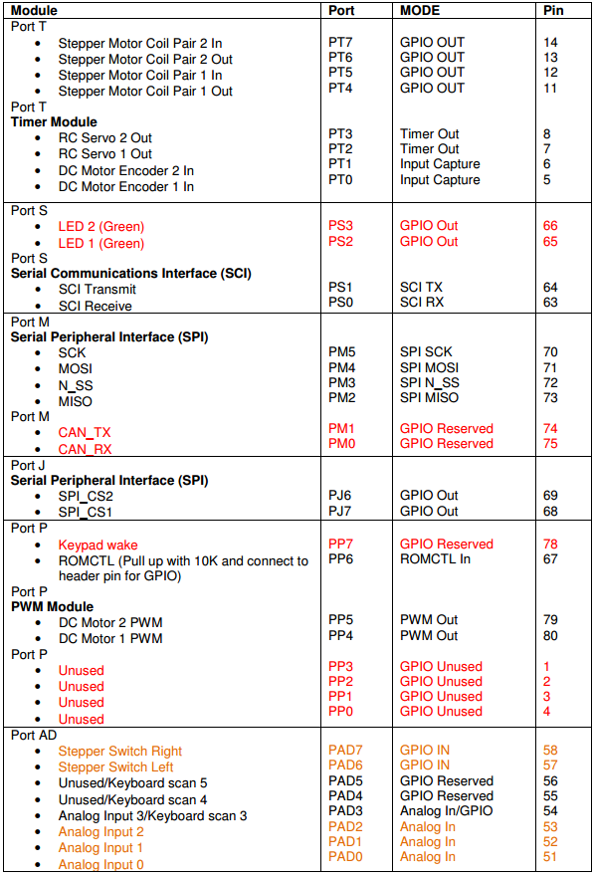

### Ports assignment cont…

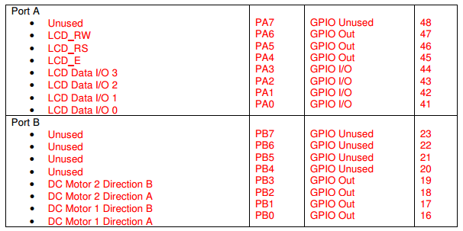

### Communication and cabling:

* TBD

### Hardware configuration:

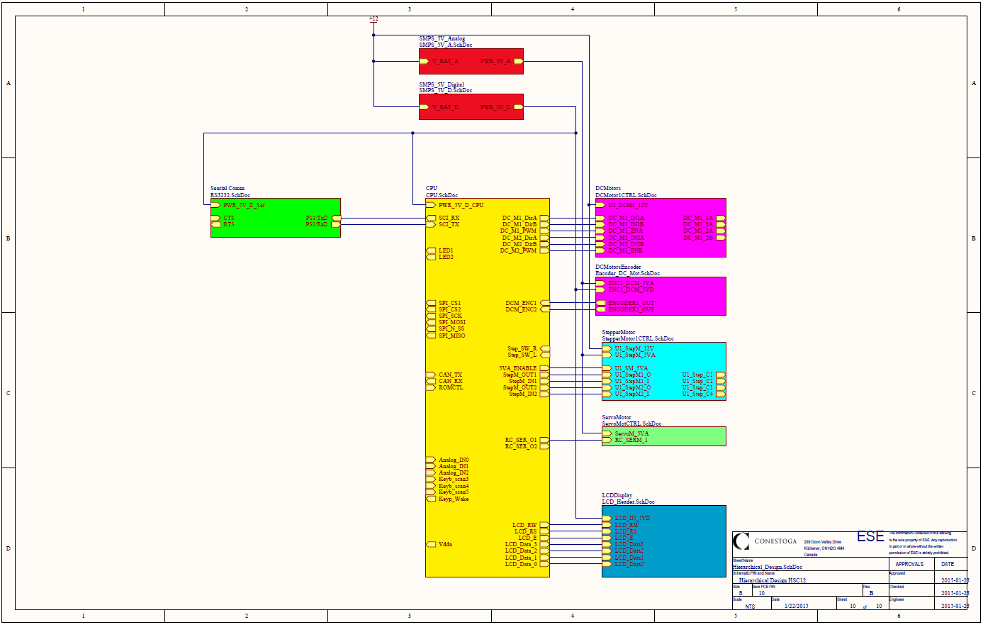

### Physical Constraints:

* Refer to refer to document 5 and 7 in 3.2 Documents List for the board physical constraints and layout options. Further details TBD
* Constraints regarding component placement – TBD

### PCB Design

* MCU connections

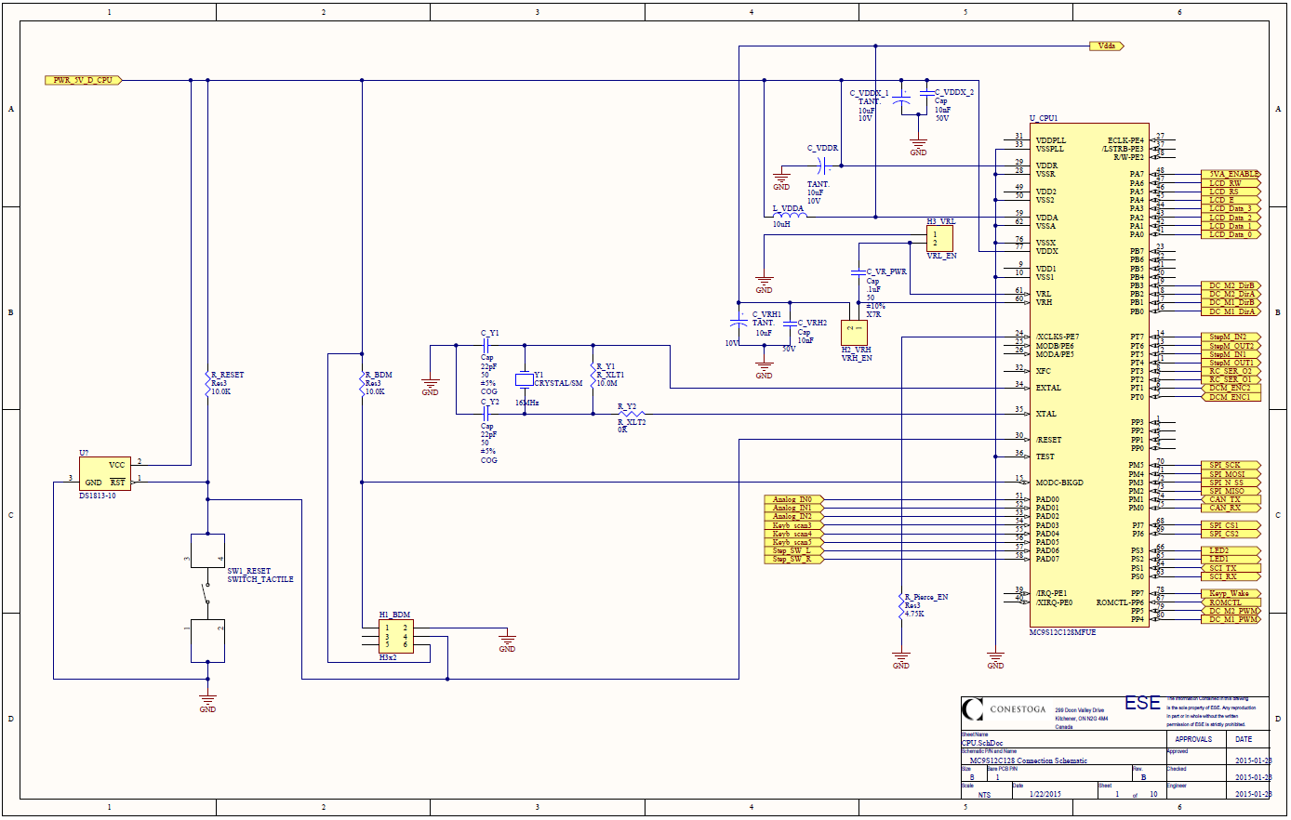

* 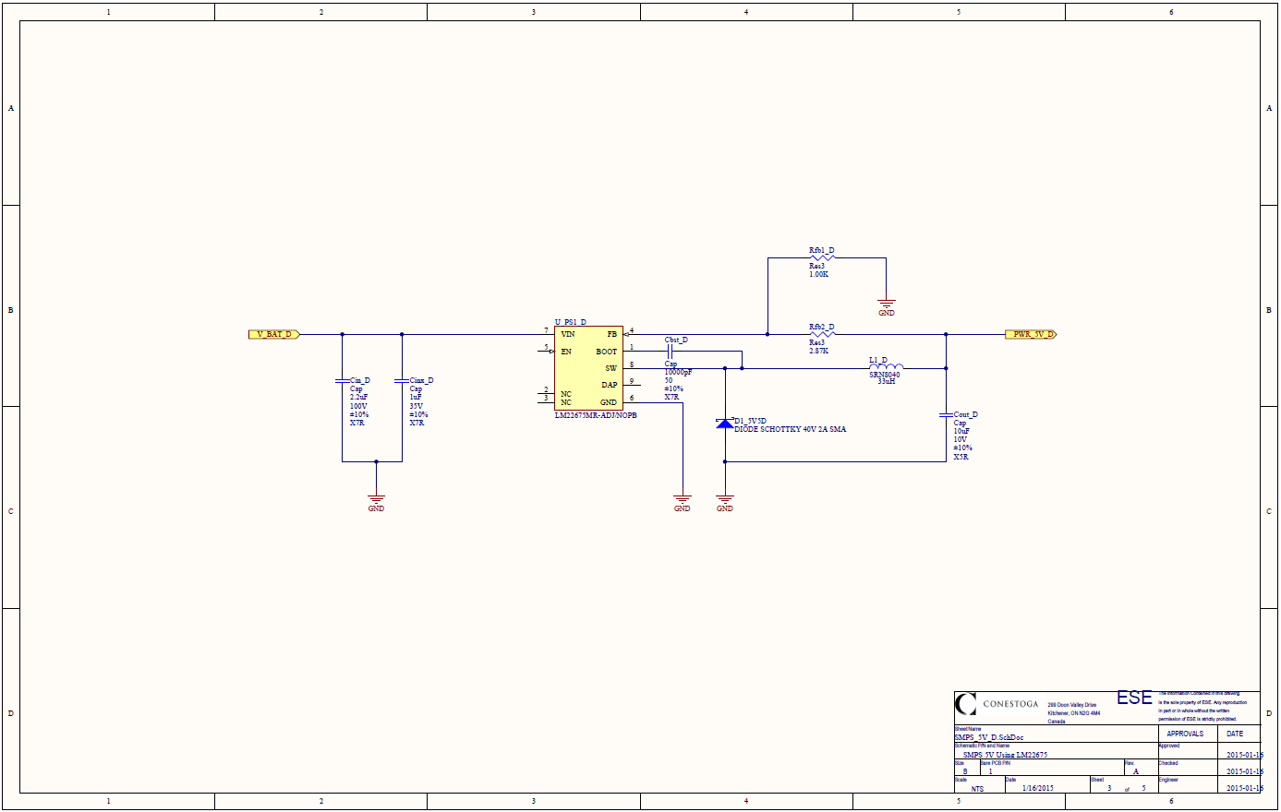SMPS 5V power supply
* RS3232 connections

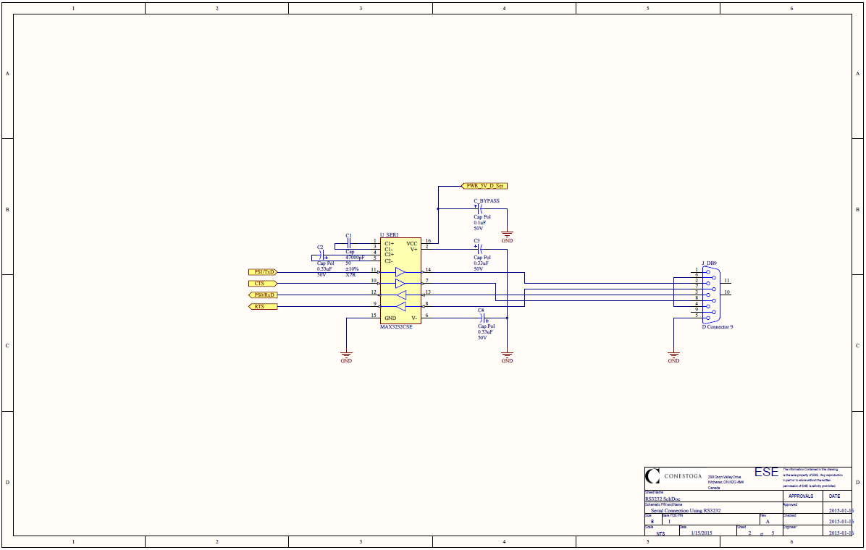

* DC motor driver

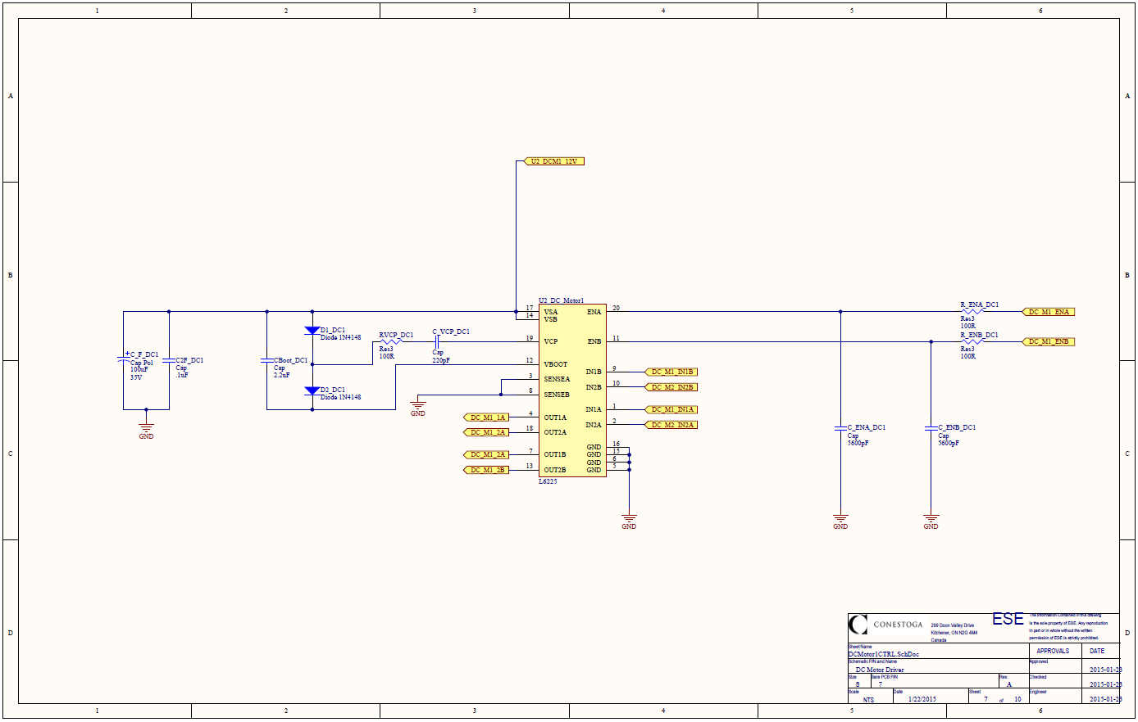

* Stepper motor driver

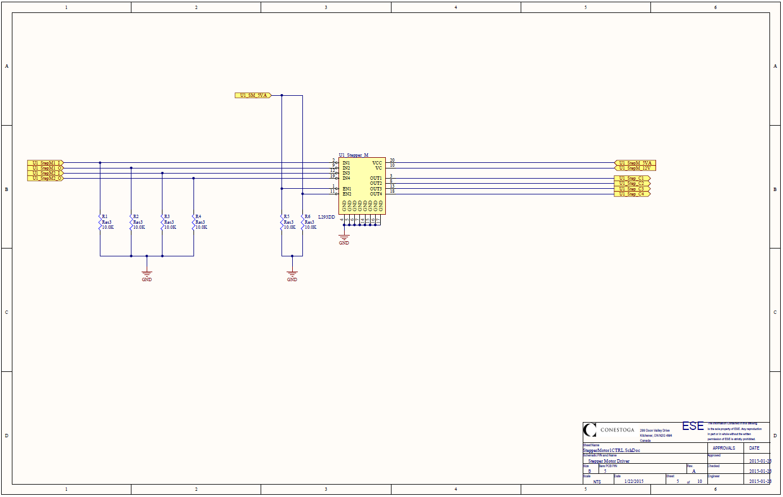

* Servo motor connections

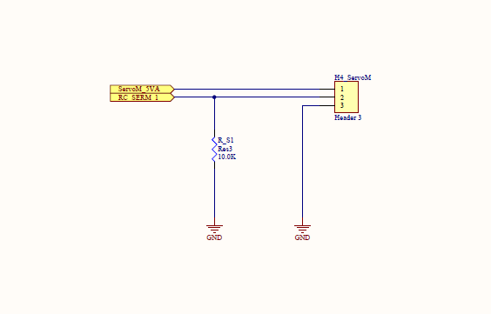

### DC motor encoder

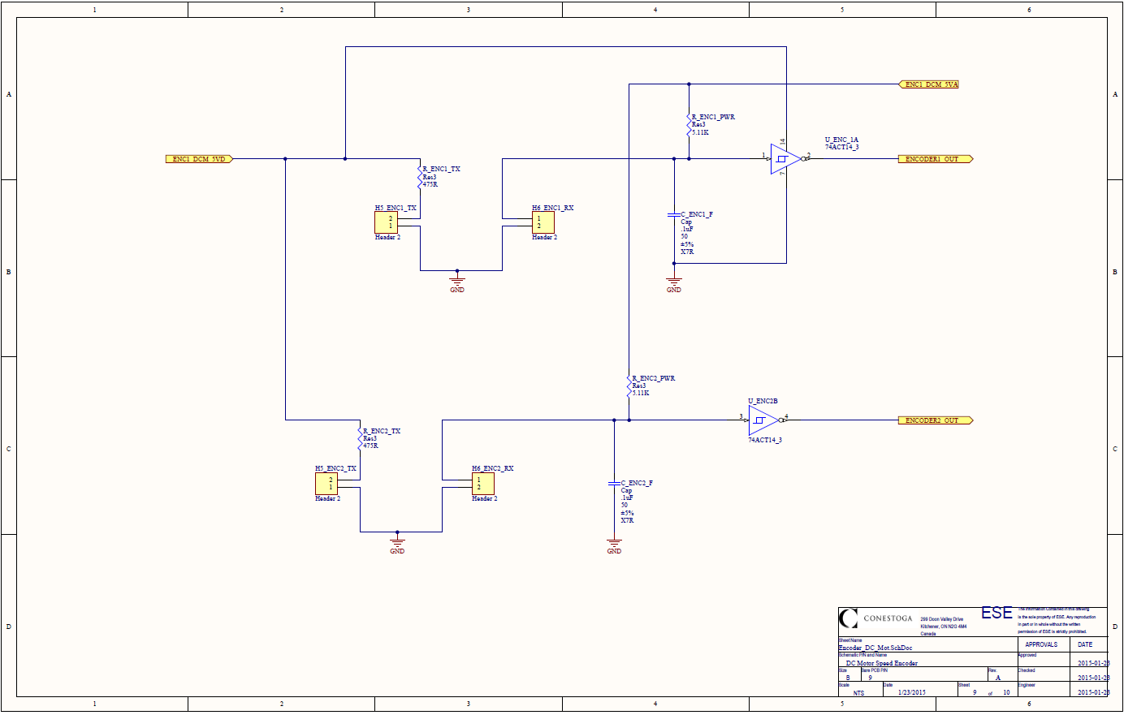

### Power requirements

* Power supplies requirements:
  + - Two 5V SMPS and one linear 3.3V power supplies are required
* Main power connection driving the 5V power supplies and motors is 12V
* Maximum power consumption per chipset – TBD and tested (it varies on configuration)

## Software Specifications

### Programming environment

* The programming development environment for the HSC12 will be Code Warrior suite (refer to document 11 in 3.2 Documents List for software documentation)
* Other software specifications TBD

# Chapter IV – Regulatory Requirements

## Purpose:

The purpose of this chapter is track regulatory requirements that shall be kept during the design phase.

## ESD Requirements

* Design for LM22675 require to comply with JEDEC document JEP155 500-V HBM
* Other requirements TBD

## Soldering Requirements

* Refer to document 12 in 3.2 Documents List for National Semiconductor products soldering specs
* IPC standard that will be applied for this project – TBD

# Reliability and Service

* The main reliability requirement is for the system to be able to run from 12V (current consumption is to be determined – dependent on configuration).